Instructions to run UWI Attendance Tracker web application

The web application is hosted at <https://classattend.firebaseapp.com> if you do not want to use the web server to host on your local machine

1. Follow the link below to install the google chrome extension we server for chrome:

<https://chrome.google.com/webstore/detail/web-server-for-chrome/ofhbbkphhbklhfoeikjpcbhemlocgigb?hl=en>

1. Click the button Add App and the extension will be installed.
2. Click the choose folder button and navigate to the public directory.

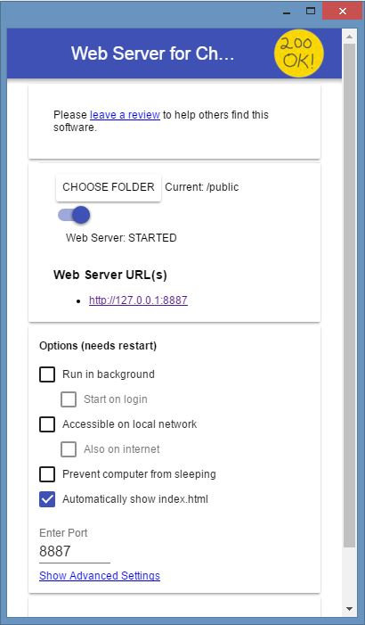

1. Ensure that the “Automatically show index.html” checkbox is selected

C:\Users\user1\Documents\COMP 3990\code_snippets\show index.JPG

1. Click the link under Web Server URL(s) and the application will open in your default browser.

C:\Users\user1\Documents\COMP 3990\code_snippets\server url.JPG